Week 1 Tutorial Activities

Task 1 - View Your Computer Information.

CPU

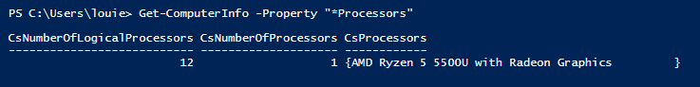

RAM in Bytes:

16498024448 Bytes or 16.5GB approximate

16777216 x 1024 = 17,179,869,184 Bytes or 17.18 GiB

Disk Sizes information:

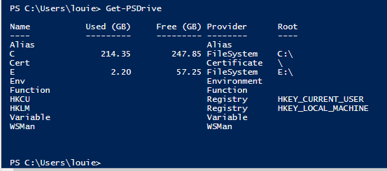

OS version:

Task 2 - Deploy Linux Web Server in VirtualBox

Download and importing the OpenWRT image in my personal laptop.

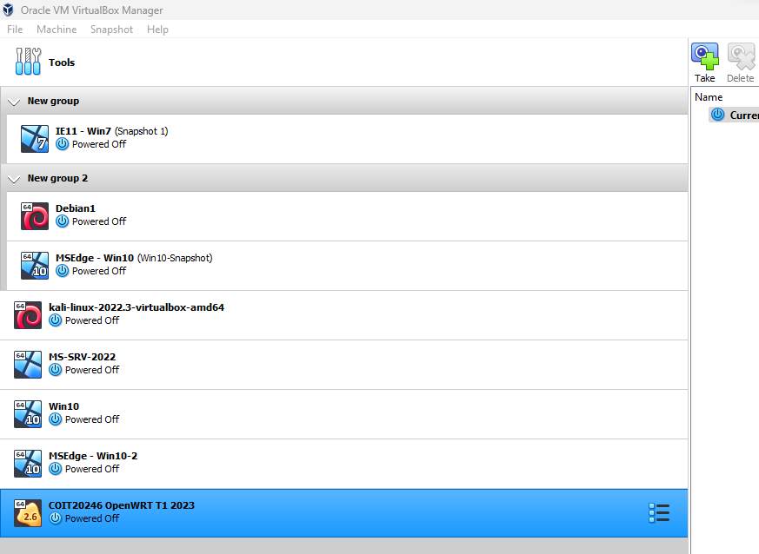

BootLoader information:

Version **2.06**

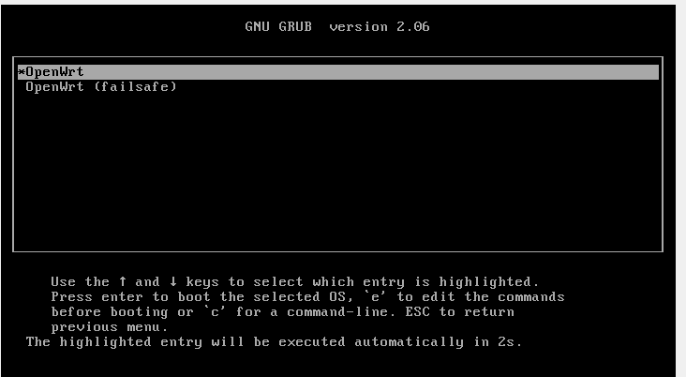

Kernel information:

Version **5.10.161**

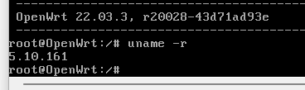

Task 3 - Browse to OpenWRT Websites.

Kernel information:

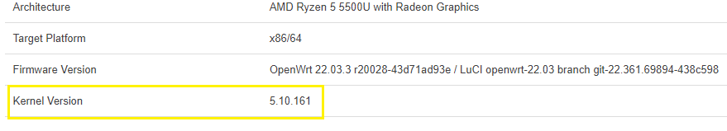

RAM information:

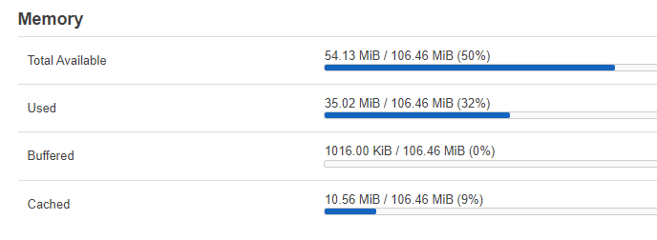

Disk Information:

OS version:



Task 4 - Practice Units and Prefixes.

Done with “Practice - Units and Prefixes” Quiz got lucky after my 2nd attempt.

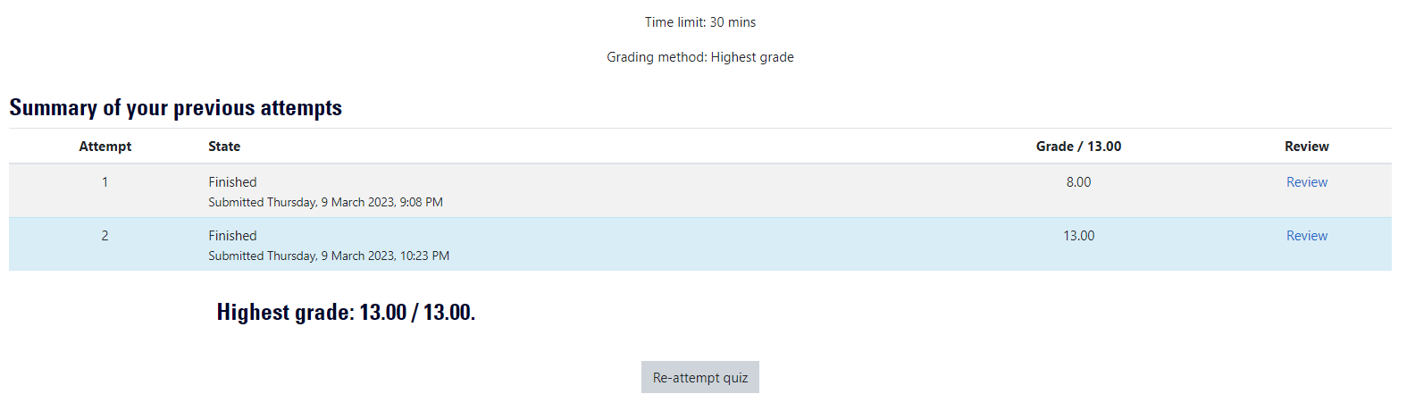

Key notes:

*Important formula for “KiB” or “MiB” conversion is 2^N / 8 and 2^N for “Kib” or “Mib”.

*Storage concepts Bytes is to “B” and Bit is to “b”, “1kib” = 1024bits

Done with “Practice - Units and Prefixes” Quiz got lucky after my 2nd attempt as well.

Key notes:

*Some questions are confusing like “4bit” but that how it is.

*Easily done using calculator as shown in the instructions.

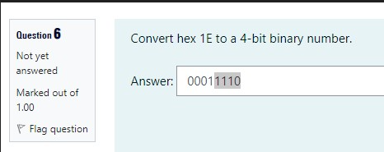

Task 5 - Create GitHub Account.

*Created a github account using CQU mail (louie.laquio@cqumail.com)

Git url: **https://github.com/laquiolo**

Key notes.

* I tried pushing object using command line console. Example command can be found after creating a repository and confirm the command via google search.

git clone https://github.com/laquiolo/COIT20245.git

git init

git add README.md

git commit -m "first commit"

git branch -M main

git remote add origin <https://github.com/laquiolo/COIT20245.git>

git push -u origin main

Task 6 - Create Microsoft Azure Account.

Create a Microsoft portal account using my personal email (louie.laquio@gmail.com).

Task 7 - Learning Reflection.

What topic in this weeks lecture or tutorial was the most difficult for you?

* The difficult topic in the lecture I would say is memory storage calculation of a computer like the CSTotalPhysicalMemory, CSPhysicallyInstalledMemory and the number notation conversion like to Bytes, Gib, GiB, Mb and kB etc.
* Numerous numbers or word terminology has been introduced in the lecture.

State the topic and briefly (two or three sentences) explain what you found difficult about that topic.

* The data representation regarding number notation and storage memory representation somewhat challenging since at first glance they seemed to have similar meaning, but they are case sensitive and must need to be focused on. Also, in the lecture there were a lot of concepts and word terminology was being discussed having hard time to remember most of them.

What steps did you take (or should you take) to help with overcoming the difficulty?

* Having to read the lecture materials helps, practicing how to perform the number notation conversion and by doing the weekly practice quizzes.
* Follow the task assignments guide it is a great way to learn and practice.